(P6) Describe the different transmission methods that may be used
Scenario
You have been working towards the marketing of your range of communications equipment. Fully describe the different functions and transmission methods used by the products you have already discussed. Your customers wish to set up a basic in-house LAN with peripheral device connection. You need to describe the connection methods available to them recommend what they need in your summary (You can copy/paste material from your research but it then needs to be summarised by you).
These methods might include:
Methods | Description of why you would choose these methods | Images
Cabling | Coaxial  Has been used for long distance communications such as the cables that connect the USA to Europe. | 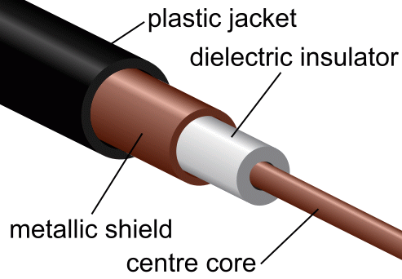
Cabling | Optical fibre  Capable of extreme data transfer rates but joining optical fibre cables is difficult so point to point connection means the less joins the better otherwise it can be very expensive to install. | 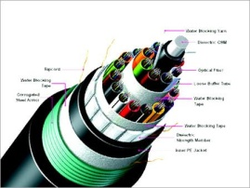
Cabling | Unshielded twisted pair (UTP)  Very cheap methods of data transfer especially over short distances but it is susceptible to interference from machinery and electronic disturbances. | 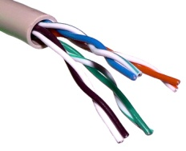
Cabling | Shielded twisted pair (STP)  This is more expensive than UTP but produces better quality data transfer due to the shielding | 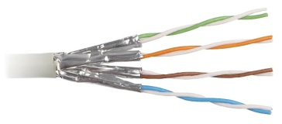
Signalling technology | Infrared
Signalling technology | Radio
Signalling technology | Microwave
Signalling technology | Satellite
SUMMARY:
For their LAN connection I recommend they need a variety of media which includes:
LAN connection method:
Reason:
Mobile connection methods:
Reason:

